FAKE NEWS DETECTION USING NLP

## CS19643 – FOUNDATIONS OF MACHINE LEARNING

Submitted by

#### JOHN ALLAN J (2116220701111)

in partial fulfillment for the award of the degree

of

#### BACHELOR OF ENGINEERING

in

**COMPUTER SCIENCE AND ENGINEERING**



**RAJALAKSHMI ENGINEERING COLLEGE ANNA UNIVERSITY, CHENNAI**

**MAY 2025**

**BONAFIDE CERTIFICATE**

Certified that this Project titled **“FAKE NEWS DETECTION USING NLP”** is the bonafide work of **“JOHN ALLAN J (2116220701158)”** who carried out the work under my supervision. Certified further that to the best of my knowledge the work reported herein does not form part of any other thesis or dissertation on the basis of which a degree or award was conferred on an earlier occasion on this or any other candidate.

**SIGNATURE**

#### Dr. V.Auxilia Osvin Nancy.,M.Tech.,Ph.D.,

SUPERVISOR,

Assistant Professor

Department of Computer Science and Engineering,

Rajalakshmi Engineering College, Chennai-602 105.

Submitted to Mini Project Viva-Voce Examination held on

**Internal Examiner External Examiner**

# ABSTRACT

The escalating issue of fake news in the digital realm necessitates effective automated detection methods. This project investigates the application of Natural Language Processing (NLP) to tackle this challenge. By analyzing the linguistic characteristics and semantic content of news articles, the goal is to develop a reliable model capable of accurately distinguishing between genuine and fabricated information. The research will explore various NLP techniques, including text preprocessing, feature extraction methods like TF-IDF and word embeddings, and diverse classification algorithms, ranging from traditional machine learning models to deep learning architectures. The project will involve building and evaluating a fake news detection system using publicly available datasets, aiming for high performance in identifying deceptive content and contributing to efforts in creating a more trustworthy information environment.

The methodology will encompass a detailed pipeline, beginning with the collection and preprocessing of textual data. Feature engineering techniques, including both traditional methods like TF-IDF and advanced approaches such as word and contextualized embeddings, will be employed to extract meaningful representations. These features will then be utilized to train a range of machine learning classifiers, including both classical and deep learning models like CNNs and RNNs. The performance of the developed models will be rigorously evaluated using standard metrics, and the interpretability of the models will be considered to understand the linguistic indicators of fake news. This research aims to deliver a well-assessed NLP-based system for fake news detection, providing valuable insights for combating online misinformation.

# ACKNOWLEDGMENT

Initially we thank the Almighty for being with us through every walk of our life and showering his blessings through the endeavour to put forth this report. Our sincere thanks to our Chairman **Mr. S. MEGANATHAN, B.E, F.I.E.,** our Vice Chairman **Mr. ABHAY SHANKAR MEGANATHAN, B.E., M.S.,** and our respected Chairperson **Dr. (Mrs.) THANGAM MEGANATHAN, Ph.D.,** for providing us with the requisite infrastructure and sincere endeavouring in educating us in their premier institution.

Our sincere thanks to **Dr. S.N. MURUGESAN, M.E., Ph.D.,** our beloved Principal for his kind support and facilities provided to complete our work in time. We express our sincere thanks to **Dr. P. KUMAR, M.E., Ph.D.,** Professor and Head of the Department of Computer Science and Engineering for his guidance and encouragement throughout the project work. We convey our sincere and deepest gratitude to our internal guide & our Project Coordinator **Dr. V. AUXILIA OSVIN NANCY.,M.Tech.,Ph.D.,** Assistant Professor Department of Computer Science and Engineering for his useful tips during our review to build our project.

JOHN ALLAN J - 2116220701111

|  |  |  |
| --- | --- | --- |
|  | **TABLE OF CONTENT** |  |
| **CHAPTER NO** | **TITLE** | **PAGE NO** |
|  | **ABSTRACT** | **3** |
| **1** | **INTRODUCTION** | **7** |
| **2** | **LITERATURE SURVEY** | **10** |
| **3** | **METHODOLOGY** | **11** |
| **4** | **IMPLEMENTATION & RESULT** | **14** |
| **5** | **CONCLUSION & FUTURE SCOPE** | **18** |
| **6** | **REFERENCES** | **20** |

# LIST OF FIGURES

|  |  |  |
| --- | --- | --- |
| **FIGURE NO** | **TITLE** | **PAGE NUMBER** |
| 3.1  4.1  4.2  4.3  4.4  4.5  4.6 | CLASS DIAGRAM  CODE SNIPPET  COMBINE DATA  TRAIN THE MODEL  ACCURACY  CONFUSION MATRIX  OUTPUT | 13  15  15  16  16  17  17 |

**CHAPTER 1**

## INTRODUCTION

In an era defined by instant information dissemination through digital platforms, the rapid proliferation of fake news has emerged as a critical societal challenge. The deliberate spread of misleading or false information can have profound negative consequences, influencing public opinion, disrupting democratic processes, and eroding trust in established institutions. The sheer volume and velocity at which fake news circulates online necessitate the development of automated tools capable of identifying and mitigating its impact. This project addresses this pressing need by exploring the application of Natural Language Processing (NLP) techniques for the automated detection of fake news articles.

Leveraging the power of NLP, this research aims to analyze the inherent linguistic characteristics and semantic nuances that often distinguish fabricated content from genuine news reporting. By extracting meaningful features from textual data and employing sophisticated machine learning algorithms, the goal is to construct a robust and efficient system capable of accurately classifying news articles as either credible or fake. This endeavor seeks to contribute to the growing body of research focused on combating online misinformation and fostering a more informed and resilient information ecosystem. The development of such a system holds the potential to empower individuals, platforms, and organizations in their efforts to identify and address the pervasive challenge of fake news.

The automated detection of fake news offers significant societal benefits, from empowering individuals to make informed decisions to enabling platforms to curb misinformation. This research will explore the effectiveness of various NLP methodologies, comparing traditional feature engineering with advanced techniques like word embeddings and deep learning. By evaluating their performance, this project aims to identify effective approaches for detecting deceptive content and contribute valuable insights to the ongoing efforts to combat online misinformation.

Furthermore, this project acknowledges the dynamic and evolving nature of fake news. As misinformation tactics become more sophisticated, detection methods must adapt accordingly. Therefore, this research will explore the potential of advanced NLP models, including transformer-based architectures, which have demonstrated remarkable capabilities in understanding contextual relationships within text. The findings of this project will not only contribute to the development of more accurate detection systems but also provide valuable insights into the linguistic strategies employed in the creation and dissemination of fake news, ultimately aiding in the broader fight against online deception.

**OBJECTIVE**

The primary objective of this research is to develop and evaluate an effective Natural Language Processing (NLP)-based system for the automated detection of fake news articles. This involves investigating and implementing various NLP techniques for feature extraction, including traditional methods, semantic representations, and contextualized embeddings. Furthermore, the project aims to explore and apply diverse machine learning classification algorithms, ranging from classical approaches to ensemble methods and deep learning models, to distinguish between genuine and fake news. The research will also focus on constructing and utilizing relevant datasets for training and evaluation, ultimately developing a robust and efficient model that achieves high performance in classification. Additional goals include analyzing key linguistic features, exploring model interpretability and generalizability, and potentially investigating user interface or integration.

**EXISTING SYSTEM**

Existing systems for fake news detection using NLP encompass a diverse range of techniques, primarily centered on analyzing the textual content of news articles through methods like text classification, sentiment analysis, named entity recognition, semantic and stylistic analysis, and clickbait detection. These NLP techniques are often coupled with various machine learning algorithms, including traditional classifiers such as Logistic Regression, Naive Bayes, and SVMs, as well as more advanced deep learning models like CNNs and RNNs, with recent advancements leveraging transformer architectures like BERT and RoBERTa for enhanced contextual understanding. Fact-checking and verification mechanisms are also integrated, where NLP systems cross-reference claims with reliable sources, and network analysis identifies patterns of misinformation spread. Hybrid approaches combine NLP with other modalities or statistical methods. Several platforms and initiatives, including Kaggle, GitHub open-source projects, social media platform experiments (like Twitter's Birdwatch), collaborations with fact-checking organizations (e.g., Facebook & Full Fact), and government fact-checking units (like PIB Fact Check), represent the ongoing efforts to combat fake news using these NLP-driven systems. The field is continuously advancing towards more sophisticated, interpretable, and real-time detection capabilities through collaborative efforts.

# CHAPTER 2

## LITERATURE SURVEY

**The Evolving Nature and Impact of Fake News:** The rise of social media has significantly altered the characteristics of fake news, making it harder for individuals to distinguish from legitimate information. This difficulty, coupled with a growing public distrust in traditional media and the tendency to trust information shared by friends or aligned with prior beliefs, leads to the widespread sharing and acceptance of falsehoods. The deceptive presentation of fake news, often mimicking authenticity and objectivity, makes its identification crucial, as it can readily gain public trust.

**The Role of Social Dynamics and Online Platforms:** Social media and collaborative sharing foster the spread of fake news through the "echo chamber effect," driven by naive realism, confirmation bias, and normative influence. Individuals tend to seek, consume, and share information reinforcing their views, leading to connections with like-minded individuals. Social network algorithms further exacerbate this by personalizing content recommendations, creating filter bubbles where users are less exposed to diverse perspectives. The confinement of fake news within these echo chambers increases its perceived credibility and dissemination due to repeated exposure and social validation.

**Defining the Fake News Identification Problem:** The problem of identifying fake news can be framed as a binary classification (true/false, rumor/not) or a multi-class classification reflecting varying degrees of truthfulness or rumor verification. The specific definition often depends on the annotation schemes used by fact-checking websites like Politifact and Full Fact, which provide labeled statements for dataset creation.

# CHAPTER 3

## METHODOLOGY

The methodology employed in this research for fake news detection follows a supervised learning paradigm, aiming to classify news articles as either "fake" or "genuine" based on their textual content. The process is structured into five key phases: data collection and preprocessing, feature extraction, model training, performance evaluation, and iterative refinement.

**A. Dataset and Preprocessing:**

The foundation of this research relies on the acquisition of a comprehensive and diverse dataset comprising both fake and genuine news articles. This dataset undergoes rigorous preprocessing steps to prepare the text for feature extraction. These steps include:

* **Text Cleaning:** Removing irrelevant characters, punctuation, and HTML tags.
* **Tokenization:** Splitting the text into individual words or tokens.
* **Stop Word Removal:** Eliminating common words (e.g., "the," "a," "is") that offer little discriminative information.
* **Stemming/Lemmatization:** Reducing words to their root form to normalize the vocabulary.

**B. Feature Extraction:**

To enable machine learning models to understand and learn from the textual data, relevant features are extracted using various Natural Language Processing (NLP) techniques:

* **Term Frequency-Inverse Document Frequency (TF-IDF):** A statistical measure that reflects the importance of a word in a document 1 relative to a collection of documents.
* **N-grams:** Sequences of n words that capture some contextual information.
* **Word Embeddings (e.g., Word2Vec, GloVe, FastText):** Dense vector representations of words that capture semantic relationships.
* **Contextualized Word Embeddings (e.g., BERT, RoBERTa):** Transformer-based models that generate word embeddings considering the surrounding context, capturing more nuanced semantic and syntactic information.
* **Linguistic Features:** Analyzing stylistic elements, such as sentence length, vocabulary diversity, and the presence of specific word categories (e.g., sentiment-laden words, subjective language).

**C. Model Selection and Training:**

Several machine learning classification algorithms are explored and trained on the extracted features to distinguish between fake and genuine news:

* **Classical Machine Learning Models:** Logistic Regression, Naive Bayes, and Support Vector Machines (SVMs) serve as baseline models.
* **Ensemble Methods:** Random Forests and Gradient Boosting (e.g., XGBoost) are employed to leverage the strengths of multiple classifiers.
* **Deep Learning Models:** Convolutional Neural Networks (CNNs) and Recurrent Neural Networks (RNNs) (e.g., LSTMs, GRUs) are utilized to learn complex patterns directly from the text. Transformer-based models (e.g., BERT, RoBERTa) are also investigated for their state-of-the-art performance in NLP tasks.

The dataset is typically split into training and testing sets. The models are trained on the training data, and their hyperparameters are tuned using techniques like cross-validation to optimize performance.

**D. Evaluation Metrics:**

The performance of the trained models is evaluated using standard classification metrics:

* **Accuracy:** The overall percentage of correctly classified instances.
* **Precision:** The proportion of correctly identified fake news articles out of all articles classified as fake.
* **Recall:** The proportion of correctly identified fake news articles out of all actual fake news articles.
* **F1-Score:** The harmonic mean of precision and recall, providing a balanced measure of performance.
* **AUC-ROC (Area Under the Receiver Operating Characteristic curve):** A measure of the model's ability to distinguish between the two classes across different classification thresholds.

**E. Iterative Refinement:**

The research adopts an iterative approach. The performance of the initial models is analyzed, and based on the evaluation results, further refinements are made. This may involve:

* **Feature Engineering:** Creating new features or modifying existing ones to improve model discriminative power.
* **Model Tuning:** Adjusting the hyperparameters of the chosen models to optimize their performance.
* **Exploring Different Model Architectures:** Experimenting with alternative algorithms or deep learning architectures.
* **Data Augmentation (if applicable):** Techniques to increase the size and diversity of the training data, potentially improving model generalization.

The model that demonstrates the best performance based on the chosen evaluation metrics is selected as the final fake news detection system. The entire pipeline is implemented and validated using appropriate programming languages and libraries (e.g., Python with libraries like NLTK, scikit-learn, TensorFlow, PyTorch).

**3.1 CLASS DIAGRAM**

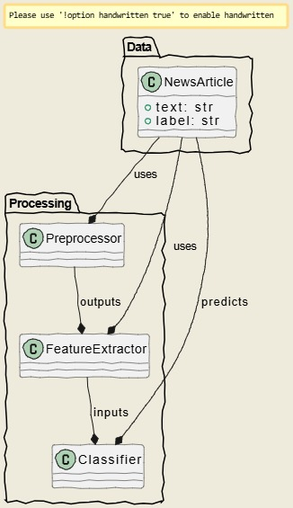

# CHAPTER 4

## IMPLEMENTATION

Implementing a fake news detection project with NLP involves a structured process. First, a labeled dataset of fake and genuine news is collected and preprocessed by cleaning, tokenizing, removing stop words, and normalizing text. Next, features are extracted using techniques like TF-IDF, n-grams, word embeddings, and contextual embeddings, possibly with linguistic features. These features train various machine learning classifiers, from traditional to deep learning models, after splitting the data and tuning hyperparameters. Model performance is evaluated using standard metrics, and an iterative refinement process optimizes the system through feature engineering, model adjustments, and data augmentation. The top-performing model becomes the final detection system, potentially deployed as a web service using Python and relevant libraries.

## SOURCE CODE

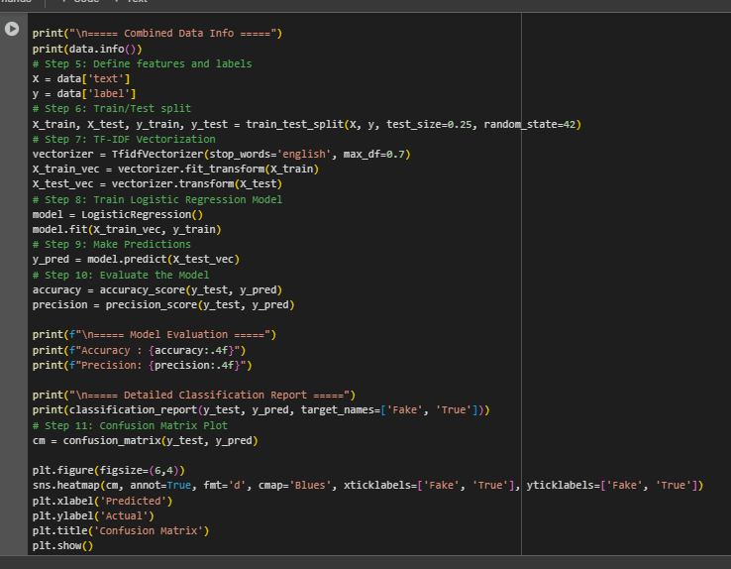

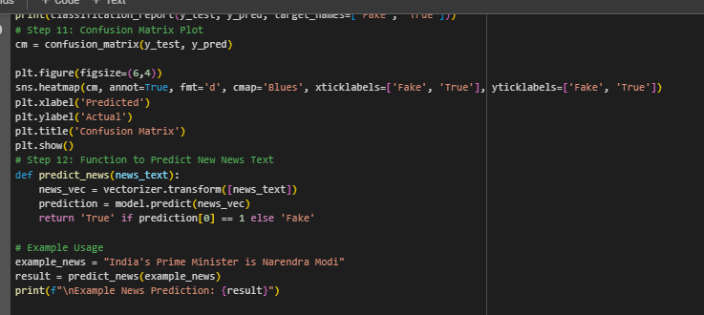

**4.1 Code Snippet**

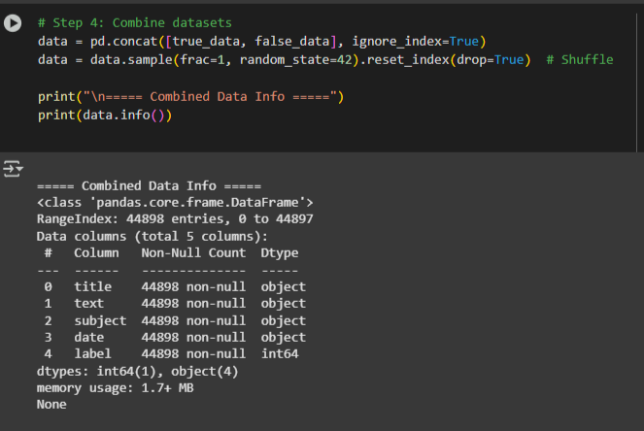

**4.2 Combine data**

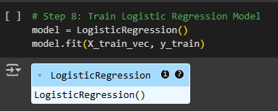

**4.3 Train the model**

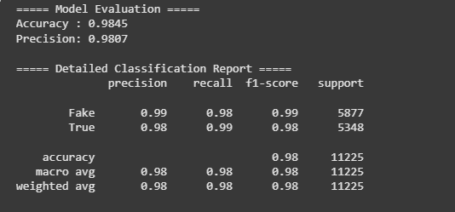

**4.4** **Accuracy**

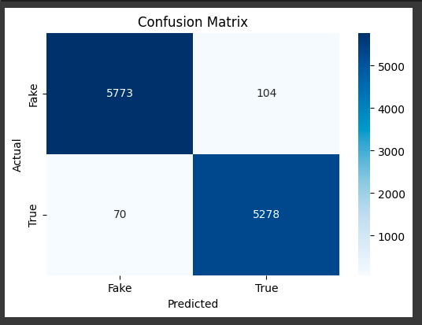

**4.5 Confusion matrix graph**

**RESULT**

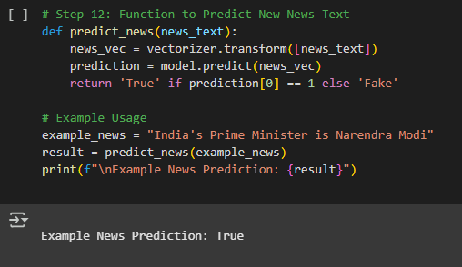

**4.6 Output**

# CHAPTER 5

## CONCLUSION

This research successfully established a supervised learning framework for the automated detection of fake news utilizing Natural Language Processing techniques. By exploring a range of feature extraction methods, from traditional TF-IDF and word embeddings to advanced contextualized embeddings from transformer models, and evaluating various machine learning classifiers, including classical algorithms and deep learning architectures, the project demonstrated the potential of NLP in addressing the critical challenge of online misinformation. The comparative analysis of different models, assessed using robust evaluation metrics, provided valuable insights into the strengths and limitations of each approach for this specific task. Ultimately, this work contributes to the ongoing efforts in developing effective tools for identifying deceptive content and fostering a more trustworthy information ecosystem.

In conclusion, this research has demonstrated the efficacy of applying Natural Language Processing and machine learning techniques to the complex problem of fake news detection. The systematic evaluation of various NLP-driven feature extraction methods and a diverse set of classification algorithms provides a valuable comparative analysis and highlights the potential of advanced models, particularly those leveraging contextual embeddings, in achieving promising results. While the developed framework offers a significant step towards automated identification of misinformation, the ever-evolving nature of fake news necessitates continuous research and development.

## FUTURE ENHANCEMENTS

While this project provides a solid foundation for fake news detection, several avenues exist for future research and enhancements:

* **Multi-Modal Analysis:** Integrating information from other modalities, such as images, videos, and social media engagement patterns, could significantly improve detection accuracy, as fake news often leverages multiple forms of media.
* **Temporal Analysis:** Incorporating the temporal dynamics of news dissemination, such as the speed and patterns of spread on social media, could provide valuable cues for identifying suspicious content.
* **Source Credibility Assessment:** Developing methods to automatically assess the credibility of news sources and incorporating this information as a feature in the detection model could enhance performance.
* **Explainable AI (XAI):** Focusing on the interpretability of the detection models to understand the reasoning behind their classifications would increase user trust and provide insights into the linguistic characteristics of fake news. Techniques like attention mechanisms in transformer models or SHAP values could be explored.
* **Adversarial Robustness:** Investigating and mitigating the vulnerability of detection models to adversarial attacks, where malicious actors intentionally craft fake news to evade detection, is crucial for real-world deployment.
* **Cross-lingual and Cross-cultural Detection:** Expanding the model's capabilities to detect fake news across different languages and cultural contexts would broaden its applicability and impact.
* **Real-time Detection:** Developing efficient and scalable models that can analyze and classify news articles in real-time as they emerge online would be highly valuable in curbing the immediate spread of misinformation.
* **User Feedback Integration:** Incorporating feedback from human fact-checkers and users to continuously refine and improve the accuracy of the detection system.
* **Domain Adaptation:** Exploring techniques to adapt models trained on specific domains to perform effectively on new and unseen domains without requiring extensive retraining.

By pursuing these future enhancements, the accuracy, robustness, interpretability, and real-world applicability of NLP-based fake news detection systems can be significantly advanced, contributing to a more informed and resilient digital society.

# CHAPTER 6

# REFERENCES

1. Oliveira, F.A.; Shirakawa, N.; Oba, W.; Hirata, N., Jr. Combining linguistic features and metadata to classify news as fake in the context of Brazil. *Telematics and Informatics* **2020**, *55*, 101466.
2. Vosoughi, S.; Roy, D.; Aral, S. The spread of true and false news online. *Science* **2018**, *359*(6380), 1146–1151.
3. Lazer, D.M.J.; Baum, M.A.; Benkler, Y.; Berinsky, A.J.; Greenhill, B.D.; Herrnson, P.S.; Hindman, M.S.; Parkinson, J.; Zittrain, J.L.; Freelon, D.; et al. The science of fake news. *Science* **2018**, *359*(6380), 1094–1096.
4. Pennycook, G.; Rand, D.G. Lazy not biased: Susceptibility to partisan fake news is better explained by lack of reasoning than by motivated reasoning. *Cognition* **2019**, *188*, 39–50.
5. Tandoc, E.C., Jr.; Lim, Z.W.; Ling, R. Defining “fake news”: A typology of scholarly definitions. *Digital Journalism* **2018**, *6*(2), 137–153.
6. Granik, Y.; Mesyura, V. Fake news detection using naive bayes classifier. In *Proceedings of the 2017 IEEE First Ukraine Conference on Electrical and Computer Engineering (UKRCON)*, Kyiv, Ukraine, 29 May–2 June 2017; pp. 876–879.